Report

Title of Research – Data Analytics for Smart transportation system
Student Name: Vaibhav

Table of Contents
Report 1
Title of Research 1
1 Abstract 4
2 Introduction 4
2.1 Background 5
2.2 Aims & objective 5
2.3 Rationale 5
2.4 Contribution 6
2.5 Organization of report 6
3 Literature Review 7
Methodology 8
3.1 Data Collection Method: 8
3.2 Dataset interpretation 8
3.3 Primary Data Variable & attribute details 9
3.4 Data analysis method 9
3.5 Decision tree algorithm 9
4 Level 1: Descriptive statistics 11
4.1 Detail & interpretation 11
4.2 Attribute selection 11
5 Level 2: inferential statistics (Normal Distribution) 12
5.1 Normal distribution using excel 12
5.2 Normal distribution chart 13
5.3 Description 13
6 Level 3: Machine Learning Decision tree Presentation in python 14
7 Findings and discussion 19
8 Recommendations 21
9 Conclusion and Future Work 22
9.1 Revision Improved 22
Bibliography 22
10 Appendix 24
10.1 # Marine Data Set 24
10.2 #Basic Exploratory Data analysis 24
10.3 #SNS Distribution Plot to check the accuracy of submarine 25
10.4 #Calculate probability distribution 25
10.5 # Naive Bayes Model 25
10.6 model = DecisionTreeClassifier() 26
11 Level 1: Descriptive statistics 28
11.1 Detail & interpretation 28
11.2 Attribute selection 28
12 Level 2: inferential statistics (Normal Distribution) 29
12.1 Normal distribution using excel 29
12.2 Normal distribution chart 30
12.3 Description 30
13 Level 3: Machine learning decision tree 31
13.1 Python Presentation 31

Abstract
Decision tree algorithm recognized as non-parametric supervised machine learning algorithm, supervised machine learning method based on classification and regression learning technique. Primary data has been collected from university portal which based on submarine system so needs to investigate the smart transportation system in order to investigate the submarine system, it has been analysed and predicted with accuracy score of 78% of decision tree classifier of machine learning , data analytics tasks has been performed in python. Secondary data has been collected previous research and publication including peer review journals sites, with impact factor journal article this research does not harm any human being during research findings. Machine learning algorithm recognized as one of the best data analytics technique to explore smart transport system accuracy by building decision tree algorithm.

Introduction
(Howard, A.J., Lee, Woodbridge, D.M.K., 2018) smart transportation system was one of the best choice for building the smart cities and smart education system. the smart transportation system based on machine learning algorithm pattern, which essentially needs to run the various issues and challenges, the goal of smart transportation system has been used with based on IOT system, internet of thing devices widely used for the building of smart home system and smart cab system, at UK various cities has been developed and organized which is based on smart transportation system. we used the marine dataset which is part of transportation system, mostly marine shipment used by military agent to defend the countries asset, the smart submarine system has been analyzed by using the data analytics of machine learning algorithm based on decision tree classifier algorithm, decision tree classifier algorithm used to predict the accuracy score and submarine air quality and shipment load accuracy by deploying the python based classifier in jupyter notebook. We explore submarine prediction and accuracy which has been tested and visualize by mean of Seaborn library and plot them to predict the dataset cleaning purposes with the help of SNS heat map classifier. Comparatively multinomial naïve bays classifier the method of decision tree based on prediction of either this probability is true and false for the detection of spam text and spam emails, by using decision tree algorithm in the python it develop the sustainable accuracy tester in order to optimize the running task.

Background
Several findings based on average speed and congested period of time to view and validate the presentation of algorithm. (Jan, B., Farman, H., 2019) designing the smart cities with the help of smart transportation which used to manage & organize the traffic situation and captain situation, the objectives of the administration is basically used to refine the product and achieve the great outcome. The internet of things and big data analytics approach has been widely used in various areas, which was measured on IOT devices, the designing and planning concept of smart transportation which needs to control the smart system of smart cities, smart homes and smart industries. The analyzing of big data analytics with conventional engineering technique, the smart conventional method which based on Hadoop and big data analytics and system to proceed the performance of data analytics and data analysis, in which various data analytics method has been used to predict and analyzed. The system has been divided into four layers data collection and data acquisition method, the internal layer has been connected with the neural network layer to proceed the neurons and analyzed the neuron system, practically I has been analyzed and predicted with the based on various data analytics method.

Aims & objective
Aim of this research to produce data analytics by using all statistical functions and objective of this research to produce best quality score of machine learning programming.

Rationale
The Europe Brazil collaboration based on big data scientific research by using the cloud centric approach, official city administration working with information & technology teams to organized and manage the sustainable environment of data and big data analytics system. Python based machine learning matching algorithm used to predict the transport speed, patron consumptions and average weighted mean of the derived transportation system. Exploring the programming platform with application programing layer it allows the smart transport system in order to obtain the high density and availability of the data & source with respect to validation and testing the situation. Python application programming interface used to manage and organized the rapid transport system of smart cities application. The supervised and unsupervised machine learning data analytics method proceed on naïve bays classifier and support vector machine classifier as well based on logistic regression application to enhance the feature selection mechanism the best way to organize the method of data analytics and data analysis based on the pattern of identification of the problem to challenge the solution. Decision tree classifier algorithms works efficiently to refine the solution and situation, the working criteria of IOT devices based on internet sharing and data sharing network exploration of programming framework needs extra effort and time to obtain the best accuracy with precision call and great F1 score. The accuracy based on 85% to 91% to test and validate the dataset, the submarine dataset contains various blank values, non-data which does not able to analyze in python studio.

Contribution
The problem of NP hard problem of to process the NLP problem various natural language processing algorithm has been works efficiently with naïve bays classifier method as well as support vector machine classifier method. The highest frequency of F1 score with precision call depends on internal neuron layers of the decision tree classifier, and the hidden outcomes has been validated and tested proposed upon the validation method of testing the data sets of the variables. The problem of learning and optimal situation with NP hard problem which needs to classify the problem in order the handle and organized the pattern of classification technique of supervised machine learning algorithm. The supervised method of machine learning based on NP hard problem to get the efficient score needs to classify the dataset into two portions such as testing phase and training phase of the dataset. Decision tree learner based on biased trees method to classify the situation in some situation the dataset has been classified and analysed based on the requested feedback of the internal system of classification algorithm.

Organization of report
Level 1: descriptive statistics
Level 2: inferential statistics
Level 4: Machine learning decision tree.

Literature Review
(Babar, M. Arif, F., 2019.) Real time data processing system based on machine learning data analytics classifier, which extract the information from the smart transportation system in order to validate and optimize the frequency of outcomes in the form of F1 score and precision call of support vector machine classifier, logistic regression, and naïve bays classifier of machine leaning used to predict and analyze the dataset of smart transport system based on smart IOT device system which enable the smart cap to be monitor and predict the passenger activity which was based on prediction method. The method of analyzing and predicting the outcomes of passenger attributes with respect of various pattern of data frame object. Smart transportation system which based on artificial intelligence mechanism analyzed and predicted the values based on the different parameter of machine learning method. Smart transportation system central stake of life which is measured on different parameter and scale, smart transport system based on sensor and device to control the vehicle navigation system of cars, the navigation system of cars manage the traffic signal as well it also provides the facility to recognize the number plate recognition system which is based on machine learning prediction and detection method, it also detect the speed of car, which facilitate the cap captain to be analyzed the traffic from both direction in bi direction and uni directional method. Smart transportation system architecture based on data analytics and data analysis which has been reformed in various time to improve the efficiency of the smart system as well as to improve the system. the smart transportation system has been using the big data analytics and machine learning pattern to recognize the smart transportation system which has been based on IOT based system, the IOT based smart transportation system based on efficient and predict the high accuracy with machine learning modeling method, it automate the frequency and it automate the level of data analytics system. The proposed architecture provides the generic solution for smart transport planning and integrated system. (Khazaei, H., Zareian 2016) big data analytics uses the various deep learning prediction method as well as machine learning prediction to validate the outcomes with based on the classification learning method it has been come to validate the result which would be analyzed with machine learning supervised method and unsupervised method. The platform based on clustered algorithm to refine the algorithm, it works with traffic planner to proceed the result, data analytics and management modeling which has been analyzed with support vector machine and decision tree classifier method, to achieve the highest frequency of the dataset. The application layer of Hadoop and spark works with data processing layer, the smart community citizen works together in order to achieve the smart community citizen using the event decision making and event handler to process the decision mechanism based on named data mechanism including with networking layer. (Fiore, S., Elia, D., 2019) for the management of smart urban transportation the method of big data and data analytics platform used to achieve the goal of IOT based system which has been recognized and organized with machine learning based approach. Urban transportation relies on heterogeneous data system and has been recognized with various protocol method the method of machine learning prediction and analysis method widely used by the various researcher during the past data analytics framework.
Methodology
The methodology of this research based on decision tree classifier, this algorithm works on python programing with Sklearn library and pandas library, python libraries works efficiently to obtain the high classification and categorization method of getting the highest outcomes of machine learning method as well deep learning method.

Data Collection Method:
Secondary data has been collected from reputed peer reviews journals sites, and primary data has been collected from university portal sites, primary data based on submarine data, which needs to analyse the smart transportation system of smart cities in the development of smart citizen and responsible citizen of the UK. Moreover the secondary data has been collected for IEEE journals sites, IEEE XPLORE sites, and ACM library as well as MDPI research and also based on Google scholar research. (Fiore, S., Elia, D., 2019)

Dataset interpretation
Marine dataset which present the smart transport system, to measure the level sea and level of air pressure with respect of visibility stance of wave period and wave time, mostly the wave is high during the monsoon season, so the pressure of sea is high and does not accurately works due to high waves, so by analyzing the machine learning based prediction it suggest the solution to boost the smart transport system of sea.

Primary Data Variable & attribute details
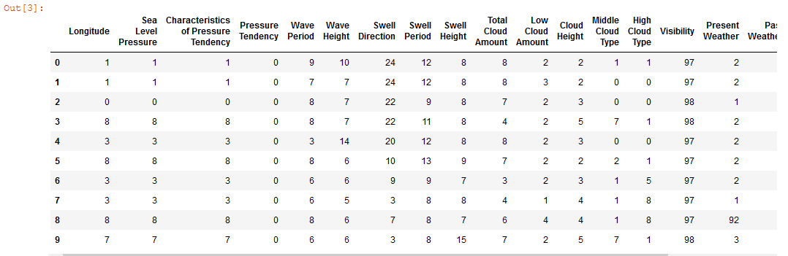
Dataset contains the submarine which has been imported and process by using panda’s library in the python shell of jupyter notebook, the jupyter notebook is considering one of the best method of data analytics. Machine learning work very well to achieve the great outcome of the dataset.

Data analysis method
Data analysis method has been based on python coding and python programming, python programming considered one of the best programming modules in these in order to achieve the great accuracy and great outcomes of dataset. The decision tree classifier works efficiently to achieve the better performance of the dataset.

Decision tree algorithm
Decision tree algorithm recognized as non-parametric supervised machine learning algorithm, supervised machine learning method based on classification and regression learning method. The objective of the decision tree algorithm is target the variables (Scikit – learn 2021) , the target variable obtain to perform the operation of target variable which has been measured and classified based on the pattern of perceive constant approximation method.
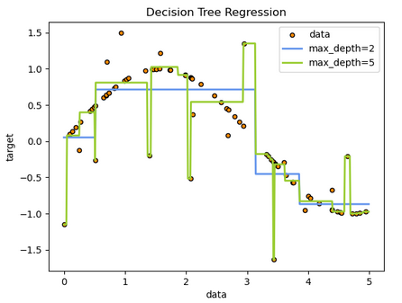
Figure: decision tree regression
The advantage of decision tree algorithm is very simple and easy to obtain the outcomes which essentially demands by the user on dataset presentation. The score accuracy based on 75% to 85% which has been very high level of score to present the classical problem. To handle the numerical and categorical data the specialized analytical method has been processed on different pattern which has been highly recommended for the researcher. Possible validation method has been used the statistical model, in comparison with neural network of deep learning algorithm, the classification and categorization method has been high. Using the white box model of observed situations which has been highly available to obtain the results of decision tree algorithm. The disadvantages of decision tree is that researcher and developer uses the decision tree model to achieve the high tree model which is very complex to understand and present them. Decision tree is unstable because of small variation of numeric data and object data, the data has been composed and measured with the analytical mechanism and method. The predictions of decision tree is never smooth and nor continuous the perceived approximation method has been analysed and predicted on target variable only, if the independent and dependent variable needs to classify again then all of the decision tree strategies needs to revised them again.

Level 1: Descriptive statistics
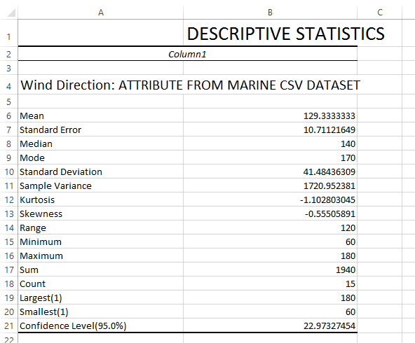

Detail & interpretation
Descriptive statistics used to describe the dataset statistical values and its useful way to analyse the dataset by using excel worksheet

Attribute selection
Wind direction has been selected from marine csv dataset and target the only 12 values

Level 2: inferential statistics (Normal Distribution)

Normal distribution using excel
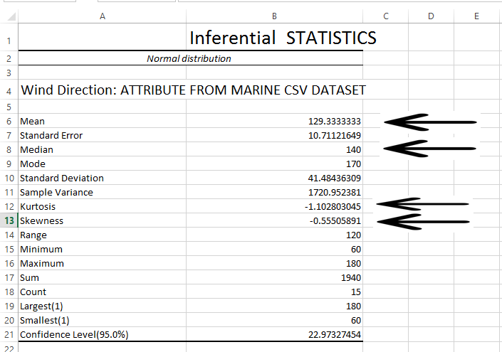
- Mean 129.33
- Median 10.71
- Kurtosis -1.10
- Skewness -0.555

Normal distribution chart
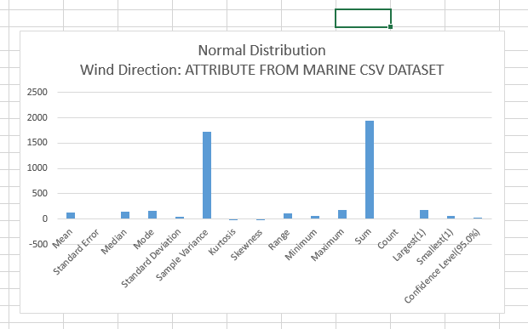

Description
Normal distribution using excel sheet to check the mean value and median value beside this kurtosis and Skewness validate the normal level in the dataset. It also validate the level of positioned value such as positive and negative direction of the dataset. Either the data value distributed to normal direction or not. The proper term of probability in bell curve by selecting the mean value in the positive direction of the datasets attribute value, trendy a normal distribution the mean is zero and the normal nonconformity is 1. It has zero tilt and a kurtosis of 3. Normal deliveries are balanced, but not all regular deliveries are usual.

Level 3: Machine Learning Decision tree Presentation in python
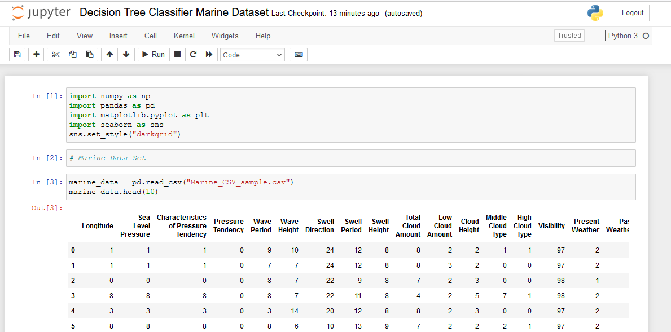
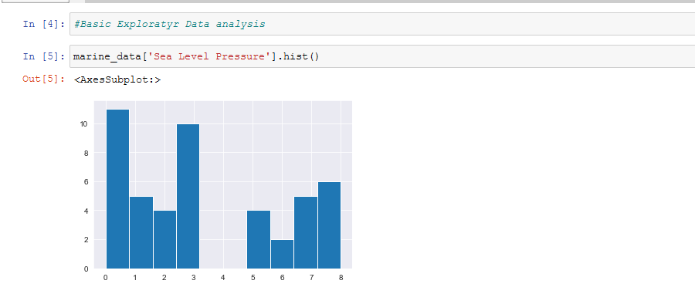
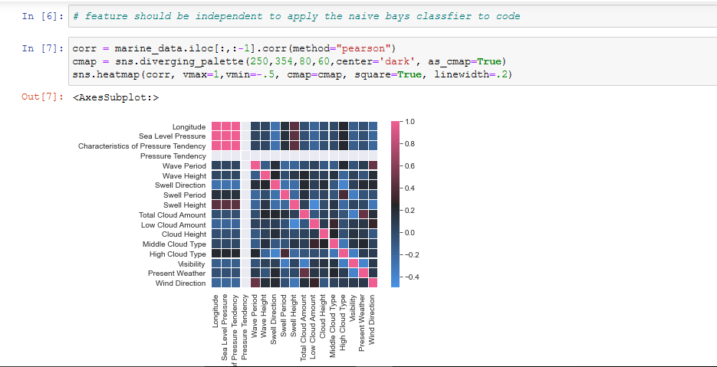
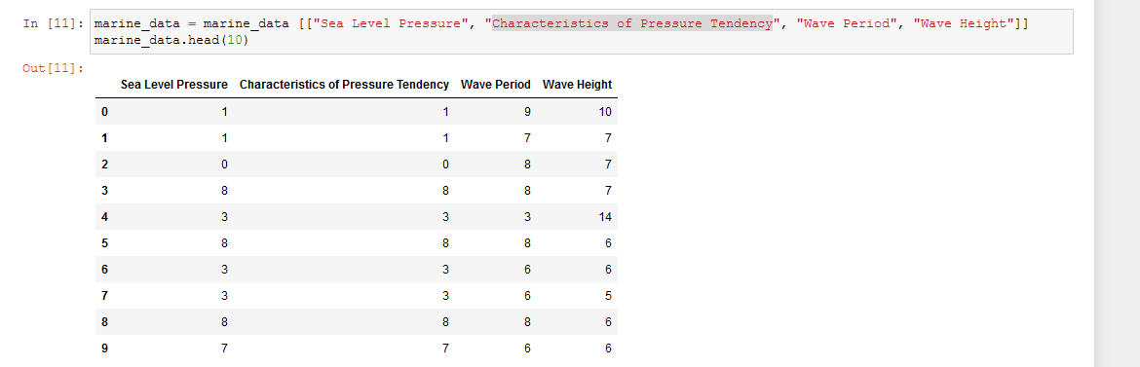
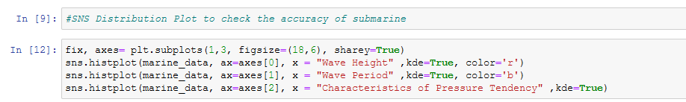
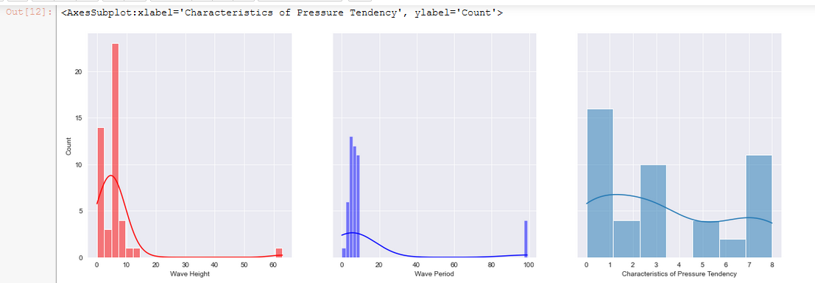
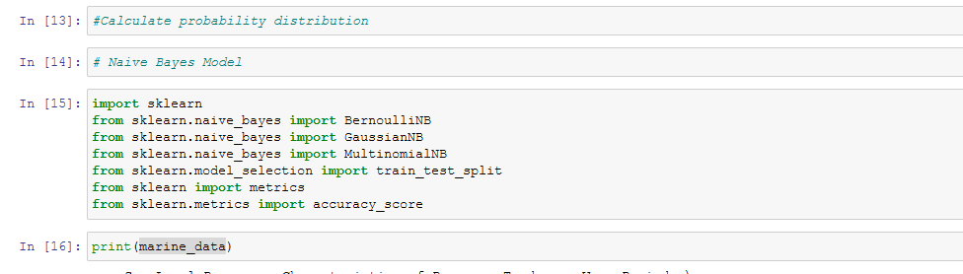
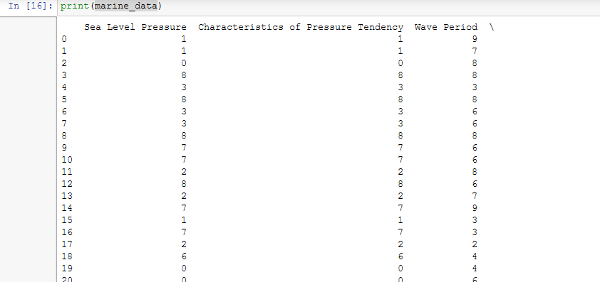
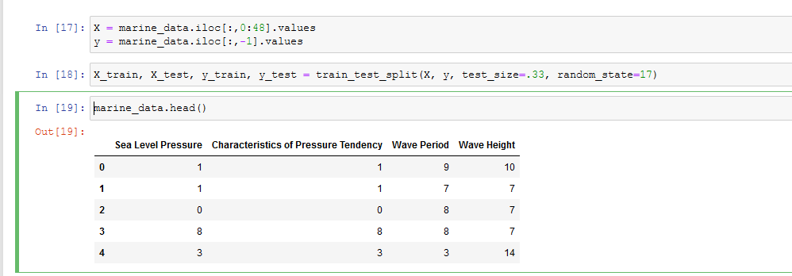
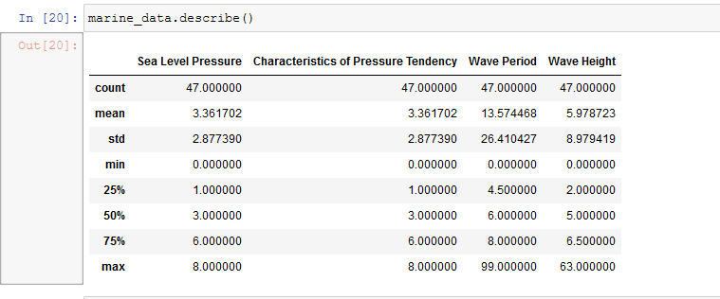
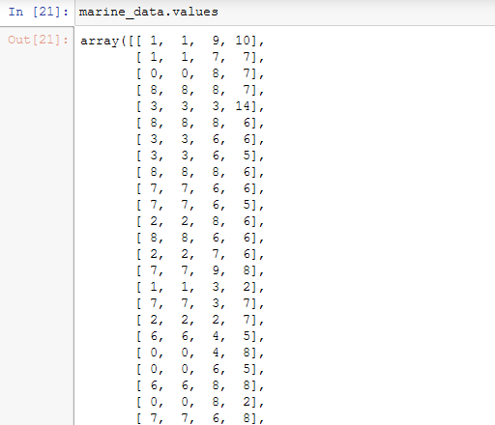
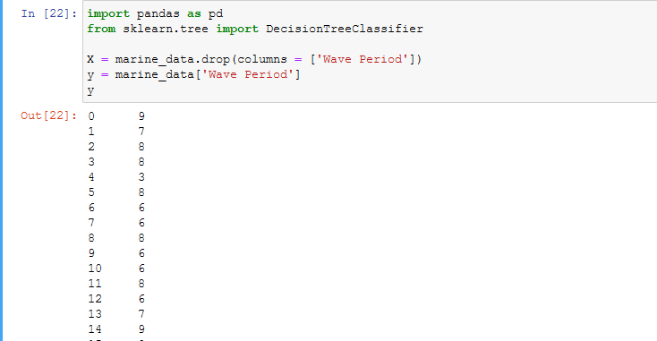
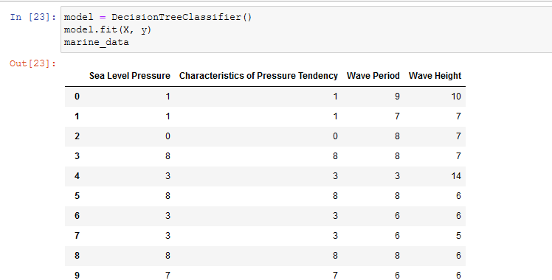
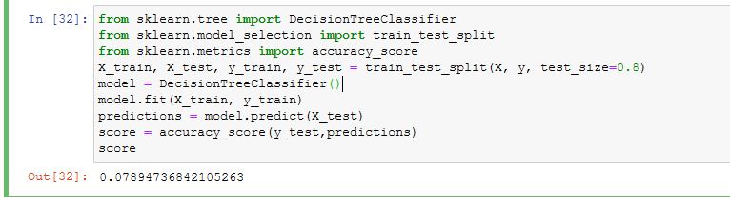

Classification
The classicisation method by using the python SKLEARN library, the class capable of performing multi-class classification based on the dataset. The feature selection method of classification learning technique which has been analysed and predicted n-sample and n-features, the target variable of dataset needs to initialize them in python. The decision tree classifier method has been classified and organized with various method of dataset in terms of numeric array, it classify only integer and float dataset, object and string data does not able to classify them, so solves this situation the machine learning TFIDF and token Vectorizer and naïve bays algorithm works on prediction and learning method. The text based analysis based on exploratory data analysis it has been achieved with exploratory data model with python natural language processing algorithm beside this deep learning method actively works in this forum. (Singh, V.K. 2018)

Findings and discussion
(Singh, V.K. 2018) decision tree based anomaly detection system based on classification learning method. The classification approach has been works very well to present the great accuracy score of the mathematical model of decision tree algorithm , beside this submarine dataset contains various null and blank values which needs to refine and adjust them to obtain the classification and regression tree outcomes the method of data cleaning has been optimized the dataset and the presented outcomes of the dataset has been need to remove the unwanted blank columns and unwanted blanks rows, the unwanted data and unwanted columns does not classify and optimized by the machine learning classifier. The decision tree modelling and multinomial naïve bays classifier works efficiently in order to present the dataset. The data visualization method has been used to produce the outcomes of the variable the framework of scatter plot and bar plot has been used to view the items of interest to visualize and analyse the outcome. The fire detection system based on IOT system and machine leaning prediction methodology has been presented previously to detect the fire and detect any vulnerability attack in the sensitive areas of location where there is secure and protected premised and needs to investigate them properly to perform the IOT based machine learning perdition method to secure the sensitive place. The IOT based fire alarm system has been developed to organized and managed the sensitive places by sending the message in real time situation to control and manage the situation. The system was designed with M-135 and sensor to protect the environment control, the embedded arduino based sensor system has been optimize the workflow. The k-nearest neighbours algorithm works to refine the decision tree pattern which has been detect and predict the fire emergency with the sensor based detection system, It enable the sensor by using decision tree and k-nearest neighbour pattern to achieve the great outcomes. Various use cases of fire detection has been recorded and performed during the testing and validation phase of machine learning accuracy to validate and test the IOT based system it has been measured and analysed by sending the protocol based mechanism to the destination node. The result has been obtains with K-NN and decision tree algorithm with highest accuracy of 93% to 95% of resultant outcome of decision tree accuracy. The condition of safety message by sending to administration control panels has been measured and organized to protect the places by the implementation of IOT based detection system, all of the development and findings has been based on smart cities and smart transportation system. (Bansal, K., Mittal, K., 2020.) smart transportation system using the IOT based mechanism for building the smart network of vehicle detection system and passenger detection system in order to analyse the prediction of cab and captain profit and loss situation, it categorized the daily routine task of traffic which has been measured on situation of the crowded car. The machine learning method to detect the ream time transport detection system has been analysed and predicted to solve the situation in crowd car roads, and the availability of passenger items of interest which has been needs more classification method. Machine learning based pothole detection system it has been detect the real time irregularities of the vehicles using internet of things devices, which based on ARDUINO system and it was designed on machine learning algorithm. The support vector machine learning method and logistic regression method, decision tree and random forest tree algorithm has been analysed and predicted which based on naïve bays, decision tree classifier method has been produced the great accuracy. The k-nearest neighbour algorithm and deep learning algorithm has been deeply works to refine and analysed the situation to predict the method. The decision tree, and support vector algorithm which has been measured analysed to predict and achieved on great outcomes.

Recommendations
It is highly recommends that the machine learning and deep learning algorithm, machine learning method has been predicted and based on supervised machine learning method, which needs to analysed and measured on decision tree pattern. The decision tree algorithm work very well compratively to solve the NP hard problem, the algorithm of NP hard completeness problem has been analysed and measured to achieve the outcomes with great score. The python based machine learning prediction method has been works efficiently & analysed on predicted algorithm, it has been solves to analyse them with great outcomes methods. The SKLEARN machine learning library works with binomial theorem to get the accuracy result by declaring the target variable. The training and testing part of dataset has been split into two portion in which the dataset has been analysed and predicted based on the decision tree classifier method. The tendency of decision tree classifier method has been used to predict and analysed the decision tree algorithm, the mechanism of classification of supervised machine learning method present the 78% accuracy result with python notebook algorithm. It is highly recommended that the decision tree classification method has been used to classify and categorize the problem, to solve the situation It has been suggested that the naïve bays classifier is also works efficiently and support vector machine classifier algorithm produced the high score and great precision call with F1 score. The accuracy outcomes of decision tree classifier comparatively less with comparison of support vector machine classifier and naïve bays classifier method, beside this logistic regression algorithm used in the data mining approach to mine the dataset with large portion of data warehousing projects. The machine learning and data mining algorithm also works in data analytics platform to view the presentation of classified machine learning algorithm. Decision tree classifier method has been sustain with tree and different tree contains integer data it has been validated on top to bottom layer of decision layer which is part of binary tree and binary classification algorithm method. The methodology of binary classification tree based on algorithm pattern and needs to classify the pattern in which various situation has been solved.

Conclusion and Future Work
This research present the machine learning supervised learning method in order to optimize the outcomes of machine learning and data analytics and data visualization task. The task to perform the supervised machine learning model which has been based on the classification machine learning prediction method, the organized approach works efficiently to do the task of data analytics which has been based on decision tree and K-nearest neighbour algorithm, the future works required to obtain the more high score by implementing the decision tree algorithm.
from sklearn.tree import DecisionTreeClassifier
from sklearn.model_selection import train_test_split
from sklearn.metrics import accuracy_score
X_train, X_test, y_train, y_test = train_test_split(X, y, test_size=0.8)
model = DecisionTreeClassifier()
model.fit(X_train, y_train)
predictions = model.predict(X_test)
score = accuracy_score(y_test,predictions)
score
it get the 78% accuracy.

Revision Improved
- Python coding improved & added
- Dataset interpretation added
- Methods improved

Bibliography
Howard, A.J., Lee, T., Mahar, S., Intrevado, P. and Woodbridge, D.M.K., (2018), June. Distributed data analytics framework for smart transportation. In (2018) IEEE 20th International Conference on High Performance Computing and Communications; IEEE 16th International Conference on Smart City; IEEE 4th International Conference on Data Science and Systems (HPCC/SmartCity/DSS) (pp. 1374-1380). IEEE.
Babar, M. and Arif, F., (2019). Real-time data processing scheme using big data analytics in internet of things based smart transportation environment. Journal of Ambient Intelligence and Humanized Computing, 10(10), pp.4167-4177.
Khazaei, H., Zareian, S., Veleda, R. and Litoiu, M., (2016). Sipresk: A big data analytic platform for smart transportation. In Smart City 360° (pp. 419-430). Springer, Cham.
Jan, B., Farman, H., Khan, M., Talha, M. and Din, I.U., (2019). Designing a smart transportation system: An internet of things and big data approach. IEEE Wireless Communications, 26(4), pp.73-79.
Fiore, S., Elia, D., Pires, C.E., Mestre, D.G., Cappiello, C., Vitali, M., Andrade, N., Braz, T., Lezzi, D., Moraes, R. and Basso, T., (2019). An integrated big and fast data analytics platform for smart urban transportation management. IEEE Access, 7, pp.117652-117677.
Singh, V.K. and Govindarasu, M., (2018), August. Decision tree based anomaly detection for remedial action scheme in smart grid using pmu data. In (2018) IEEE Power & Energy Society General Meeting (PESGM) (pp. 1-5). IEEE.
Bhoi, S.K., Panda, S.K., Padhi, B.N., Swain, M.K., Hembram, B., Mishra, D., Mallick, C., Singh, M. and Khilar, P.M., (2018), December. Fireds-iot: A fire detection system for smart home based on iot data analytics. In (2018) International Conference on Information Technology (ICIT) (pp. 161-165). IEEE.
Bansal, K., Mittal, K., Ahuja, G., Singh, A. and Gill, S.S., (2020). DeepBus: Machine learning based real time pothole detection system for smart transportation using IoT. Internet Technology Letters, 3(3), p.e156.

Appendix
#!/usr/bin/env python
# coding: utf-8
# In[1]:
import numpy as np
import pandas as pd
import matplotlib.pyplot as plt
import seaborn as sns
sns.set_style("darkgrid")
# In[2]:

# Marine Data Set
# In[3]:
marine_data = pd.read_csv("Marine_CSV_sample.csv")
marine_data.head(10)
# In[4]:

#Basic Exploratory Data analysis
# In[5]:
marine_data['Sea Level Pressure'].hist()
# In[6]:
# feature should be independent to apply the naive bays classfier to code
# In[7]:
corr = marine_data.iloc[:,:-1].corr(method="pearson")
cmap = sns.diverging_palette(250,354,80,60,center='dark', as_cmap=True)
sns.heatmap(corr, vmax=1,vmin=-.5, cmap=cmap, square=True, linewidth=.2)
# In[11]:
marine_data = marine_data [["Sea Level Pressure", "Characteristics of Pressure Tendency", "Wave Period", "Wave Height"]]
marine_data.head(10)
# In[9]:

#SNS Distribution Plot to check the accuracy of submarine
# In[12]:
fix, axes= plt.subplots(1,3, figsize=(18,6), sharey=True)
sns.histplot(marine_data, ax=axes[0], x = "Wave Height" ,kde=True, color='r')
sns.histplot(marine_data, ax=axes[1], x = "Wave Period" ,kde=True, color='b')
sns.histplot(marine_data, ax=axes[2], x = "Characteristics of Pressure Tendency" ,kde=True)
# In[13]:

#Calculate probability distribution
# In[14]:

# Naive Bayes Model
# In[15]:
import sklearn
from sklearn.naive_bayes import BernoulliNB
from sklearn.naive_bayes import GaussianNB
from sklearn.naive_bayes import MultinomialNB
from sklearn.model_selection import train_test_split
from sklearn import metrics
from sklearn.metrics import accuracy_score
# In[16]:
print(marine_data)
# In[17]:
X = marine_data.iloc[:,0:48].values
y = marine_data.iloc[:,-1].values
# In[18]:
X_train, X_test, y_train, y_test = train_test_split(X, y, test_size=.33, random_state=17)
# In[19]:
marine_data.head()
# In[20]:
marine_data.describe()
# In[21]:
marine_data.values
# In[22]:
import pandas as pd
from sklearn.tree import DecisionTreeClassifier
X = marine_data.drop(columns = ['Wave Period'])
y = marine_data['Wave Period']
y
# In[23]:

model = DecisionTreeClassifier()
model.fit(X, y)
marine_data
# In[32]:
from sklearn.tree import DecisionTreeClassifier
from sklearn.model_selection import train_test_split
from sklearn.metrics import accuracy_score
X_train, X_test, y_train, y_test = train_test_split(X, y, test_size=0.8)
model = DecisionTreeClassifier()
model.fit(X_train, y_train)
predictions = model.predict(X_test)
score = accuracy_score(y_test,predictions)
score

Level 1: Descriptive statistics

Detail & interpretation
Descriptive statistics used to describe the dataset statistical values and its useful way to analyse the dataset by using excel worksheet

Attribute selection
Wind direction has been selected from marine csv dataset and target the only 12 values

Level 2: inferential statistics (Normal Distribution)

Normal distribution using excel
- Mean 129.33
- Median 10.71
- Kurtosis -1.10
- Skewness -0.555

Normal distribution chart

Description
Normal distribution using excel sheet to check the mean value and median value beside this kurtosis and Skewness validate the normal level in the dataset. It also validate the level of positioned value such as positive and negative direction of the dataset. Either the data value distributed to normal direction or not. The proper term of probability in bell curve by selecting the mean value in the positive direction of the datasets attribute value, trendy a normal distribution the mean is zero and the normal nonconformity is 1. It has zero tilt and a kurtosis of 3. Normal deliveries are balanced, but not all regular deliveries are usual.

Level 3: Machine learning decision tree

Python Presentation

